Siberian Swan size chart

Each model comes in S, M, H sole firmness* level
Pointe shoes size chart  Siberian Swan (SS) length |  |  |  | Siberian Swan (SW) Width Girth** sizes
 |  |  |  | Styles «Pavlova» | Styles «Karsavina» | Width Symbols
SS / UK | USA | mm | inches | Width Girth мм | Width Girth мм
2.0 | 4½ | 205-210 | 8.3 | 186-193 | 193-200 | Х, XХ, XXХ, XXXХ
 |  |  |  | 190-197 | 197-204
 |  |  |  | 194–201 | 201-208
 |  |  |  | 198-205 | 205-212
2.5 | 5 | 210-215 | 8.5 | 189-196 | 197-204 | Х, XХ, XXХ, XXXХ
 |  |  |  | 193-200 | 201-208
 |  |  |  | 197-204 | 205-212
 |  |  |  | 201-208 | 199-204
3 | 5½ | 215-220 | 8.7 | 193-200 | 201-208 | Х, XХ, XXХ, XXXХ
 |  |  |  | 197-204 | 205-212
 |  |  |  | 201-208 | 209-216
 |  |  |  | 205-212 | 213-220
3½ | 6 | 220-225 | 8.85 | 197-204 | 205-216 | Х, XХ, XXХ, XXXХ
 |  |  |  | 201-208 | 199-216
 |  |  |  | 205-212 | 213-220
 |  |  |  | 209-216 | 219-226
4 | 6½ | 225-230 | 9.05 | 201-208 | 209-216 | Х, XХ, XXХ, XXXХ
 |  |  |  | 205-212 | 213-220
 |  |  |  | 209-216 | 217-224
 |  |  |  | 213-220 | 221-228
4½ | 7 | 230-235 | 9.25 | 203-210 | 211-219 | Х, XХ, XXХ, XXXХ
 |  |  |  | 207-214 | 215-222
 |  |  |  | 211-218 | 219-226
 |  |  |  | 215-222 | 223-220
5 | 7½ | 235-240 | 9.45 | 206-214 | 216-224 | Х, XХ, XXХ, XXXХ
 |  |  |  | 211-219 | 221-229
 |  |  |  | 216-224 | 226-234
 |  |  |  | 221-229 | 231-238
5½ | 8 | 240-245 | 9.65 | 211-219 | 221-229 | Х, XХ, XXХ, XXXХ
 |  |  |  | 216-224 | 226-234
 |  |  |  | 221-229 | 231-239
 |  |  |  | 226-234 | 236-244
6 | 8½ | 245-250 | 9.8 | 215-224 | 226-234 | Х, XХ, XXХ, XXXХ
 |  |  |  | 221-229 | 231-239
 |  |  |  | 226-234 | 236-244
 |  |  |  | 231–239 | 241-248
6½ | 9 | 250-255 | 10 | 221-229 | 231-239 | Х, XХ, XXХ, XXXХ
 |  |  |  | 226-234 | 236-244
 |  |  |  | 231-239 | 241-249
 |  |  |  | 236-244 | 246-254

*Firmness: Active Arch Support firmness levels: S (Soft), M(Medium), H (Hard)
further customizable
** Width: Width is the girth of the foot in its widest parts
Width symbols: X(Narrow), XX(Medium), XXX(Medium-Wide), XXXX (Wide)
Platforms: Wider: Karsavina
Standard: Pavlova

Proper measurement:

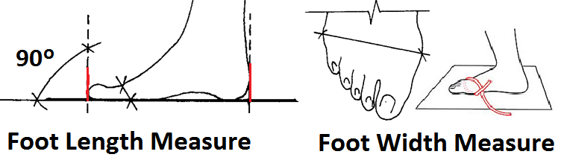

Millimeters to inches:
